Style Guide

Aesthetic:

General:

* Round/soft edges for player and environments
* Hard jagged edges for enemies and obstacles
* Should fit for an age range of 10+
* Think Ori and the Blind Forest

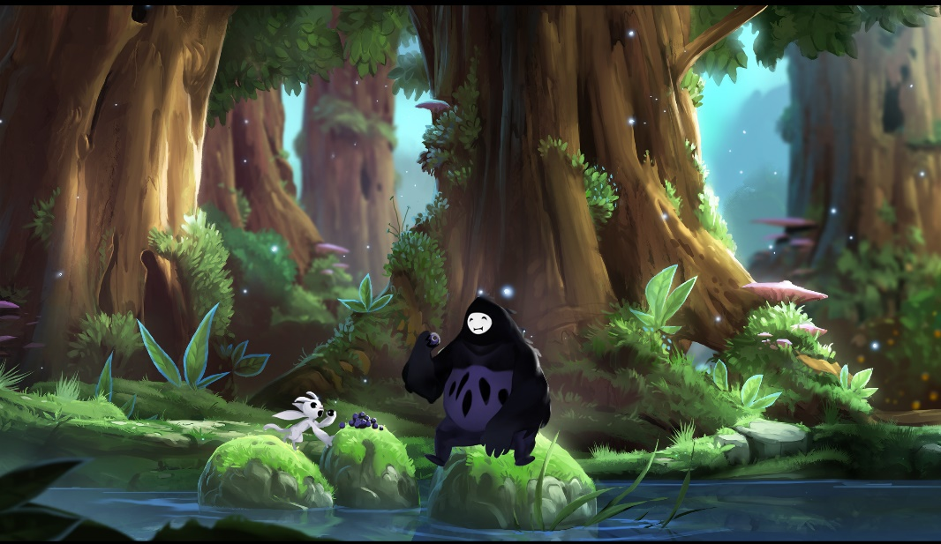

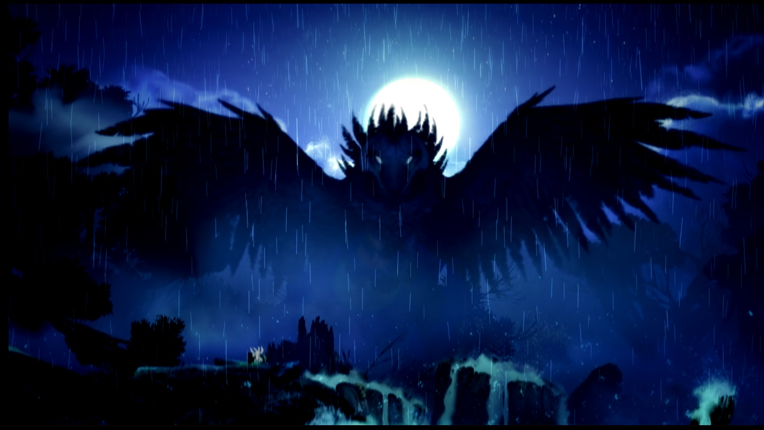

Forest Area:

* Bright/Warm natural lighting
* Needs to look alive
* Colors
  + Soft hues
  + Mostly greens and browns with some grey and blue
  + See above picture for reference

Swamp Area:

* Dark/dim natural lighting
* Needs to look like it’s dying/decaying
* Colors
  + Dark hues
  + Mostly sickly greens and browns, very little blue and grey

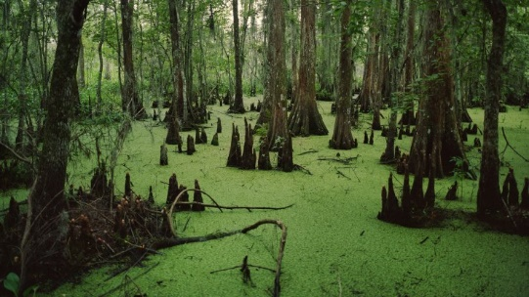

Temple Area:

* Dim artificial lighting (torches etc.)
* Needs to look broken/transforming into forest
* Colors
  + Starts with dim hues, changes into light/soft hues
  + Greys and blues
  + More and more green and brown as you venture farther and it starts changing

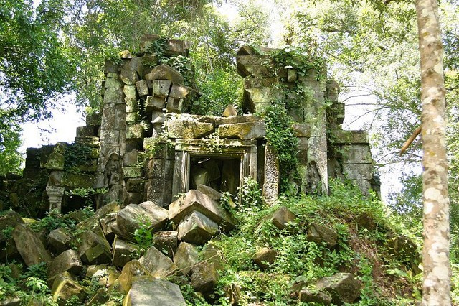

Textures:

* Needs to look painted with acrylics.
* Smooth
* Enough detail to look real but still stylized

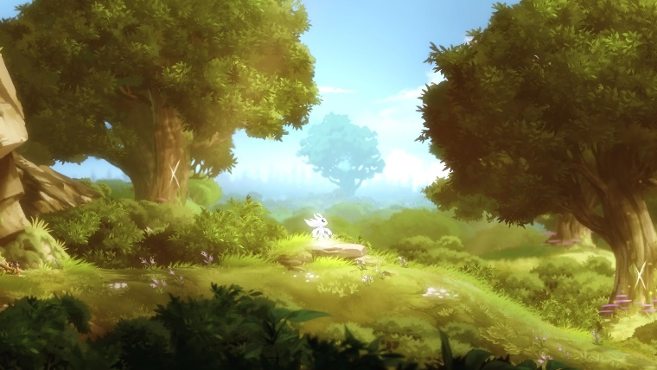 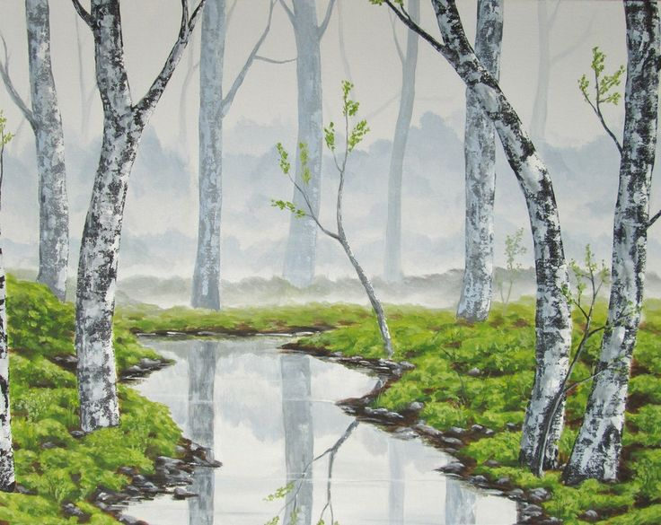

Audio:

General:

* More realistic
* NOT the focus, as such they need to be softer
* Each area can have their own walking sound, but other than that no large differences in feel

VFX:

General:

* Unity’s particle effects with some animations
  + Damaging player results in the character blinking in an out for a time
  + Collecting statues does a quick animation with particles falling from statue
  + Bouncing on bubbles causes them to disappear in a burst of particles